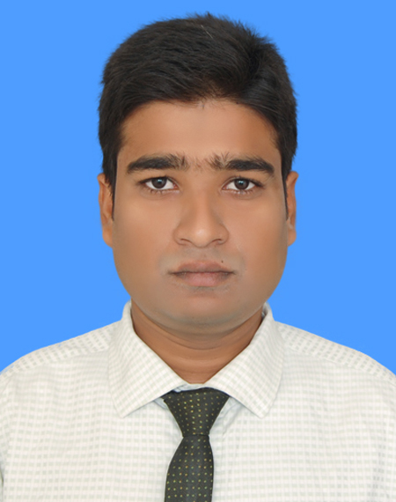

REsumE of

Sree Sujan Robidass

**Contact Address :** kashinagar, Chouddagram, Cumilla -3500

**Contact Number :** +8801917416857

**E-mail ID : sreesujanrobidass@gmail.com**

|  |
| --- |
| OBJECTIVE |
| To work for an organization which provides me the opportunity to improve my skills and knowledge to growth along with the organization objective. | |

|  |
| --- |
| Educational Qualification |

|  |  |  |  |  |  |
| --- | --- | --- | --- | --- | --- |
| **Name of Degree** | **Subject** | **Institutions** | **Year** | **Class / Division** | **Board / University** |
| MBA | Major in HRM | Hamdard University Bangladesh | 2018 | 3.70 Out of 4 | University |
| BBA | Major in Finance | Hamdard University Bangladesh | 2017 | 3.57 Out of 4 | University |
| HSC | Business Studies | Kashinagar Degree College | 2011 | 4.20 Out of 5 | Cumilla |
| SSC | Business Studies | Kashinagar B M High School | 2009 | 3.25 Out of 5 | Cumilla |

|  |
| --- |
| Working Experience |

Assistant Officer, Department of Finishing & Delivery, Meghan Pulp & Paper Mills Ltd.

Meghnaghat, Sonargaon, Narayangonj. 06.03.2017 – Present.

|  |
| --- |
| COMPUTER LITERACY |

* **Operating System:**Microsoft Office (Microsoft word, Microsoft Excel, Microsoft Power Point)
  + Internet Browsing.

|  |
| --- |
| PERSONAL ATTRIBUTES |

* + - Self-confident & positive.
    - Ability to work efficiently under pressure & meeting dealing.
    - Ability to work in teams & maintain effective communication.
    - Optimistic.
    - Ability to Research activity.
    - Conflict Management ability.

|  |
| --- |
| Interest |

* + - Play Football, Reading Book, Drama, Photography, Listening to News, Traveling.

|  |
| --- |
| Achivment |

* Obtained Scholarship from Hamdard University Bangladesh (100% Waiver)
* Obtained Scholarship from Kashinagar Degree College(100% Waiver)
* Obtained Scholarship from Kashinagar B M High School(100% Waiver)
* Got award from HamdardUniversity as a good ‘’Debater’’ in Inter Debate Tournament 2015
* Management & controller of Student Help Line coaching centre( January 1, 2014 - July 1, 2014)
* Complete computer coures
* English spoken course

|  |
| --- |
| Extra curricular activities |

* Member of Hamdard University Bangladesh Cultural Club, Debating Club, English Language Club.

|  |  |  |  |  |
| --- | --- | --- | --- | --- |
| PERSONAL INFORMATION | | | | |
| **Father’s Name** | | : | Sree Khalichran Rabidass | |
| Mother’s Name | | : | Sree Sita Rani Rabidass | |
| Present Address | | : | Newtown, Sonargaon,Narayangonj,Dhaka-1216 | |
| Permanent Address | | : | Vill: Olipur | P.O: kashinagar, |
|  | |  | P.S: Chouddagram, | Dist: Cumilla |
| Date of Birth | | : | April03, 1993 | |
| Religion | | : | Hindu | |
| Nationality | | : | Bangladeshi By Birth | |
| Marital Status | | : | Unmarried | |

|  |  |  |  |
| --- | --- | --- | --- |
| REFERENCES | | | |
| **1)** | **Prof. Dr. Md. NasimAnjum**  **Dean,**  Faculty of Business Administration  Hamdard University Bangladesh  Gazaria, Munshiganj  Mobile # +8801711301301 | **2)** | **Md. Faruk Hossain**  **Head,**  Department of Finance  Hamdard University Bangladesh  Gazaria, Munshiganj  Phone: +8801721550877  E-Mail: [faruk.par.fin@gmail.com](mailto:faruk.par.fin@gmail.com) |

|  |
| --- |
| DECLARATION |

I, the undersigned declare that the information specified in this **Resume** is true to the best of my belief and knowledge and correctly describes my experience and myself.



**___________________**

(Sree Sujan Robidass)